Global  
 Trends Analysis  
 **by Yash Kumar**

*The modern world is shaped by complex dynamics in population, health, and economics, making understanding these trends vital for informed policy-making.*

*GlobalTrends, a leading analytics firm, is dedicated to deciphering these patterns through a comprehensive analysis of the Gapminder dataset.*

*In this project, through EDA, we have uncovered the intricate relationships between demographic changes, economic development, and health advancements over recent decades.*

Load the dataset and display the first few rows.

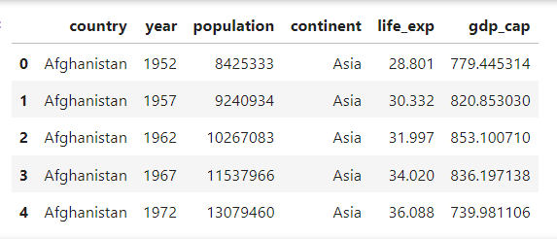

Objective Q&A:

1. How many countries does the dataset have?

Total countries = **142**



1. Create a pivot table that shows the average life expectancy for each continent and year. Index by 'continent', use 'year' as columns, and 'life_exp' as values.

**Pivot Table**

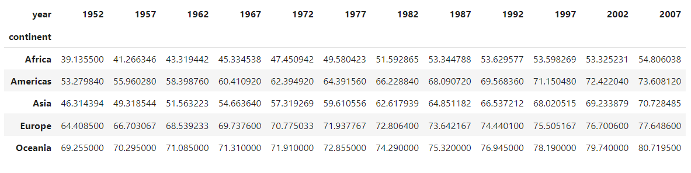

1. Which countries had a GDP per capita higher than the 75th percentile in 2007?

75th percentile gdp_cap value in = **18009** (approx whole number)



Countries with gdp_cap value higher than this are:

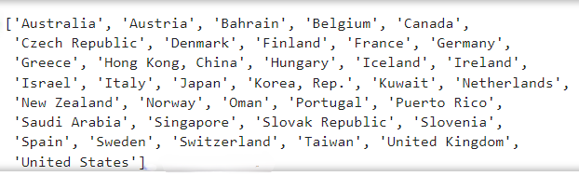

1. Categorise the 'life_exp' into 4 equally ranged bins from 'Low' to 'Very High'. Use cut to create these categorical life expectancy groups and add them as a new column 'Life_Exp_Range'.

| **Bins** | **Labels** |
| --- | --- |
| 0-25 | Low |
| 25-50 | Medium |
| 50-75 | High |
| 75-100 | Very High |

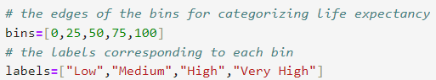

Output after categorising data frame:

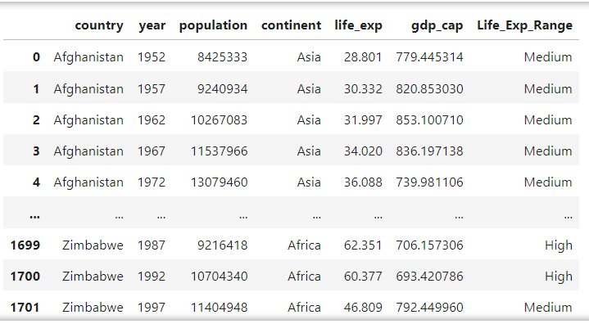

1. Identify the top 5 countries with the highest GDP per capita in 2007. Use a horizontal bar chart to display this data.

GDP per Capita (gdp_cap) is in **USD** (**$**)

| **Continent** | **avg GDP per Capita (2007)** |
| --- | --- |
| Norway | 49.4 K |
| Kuwait | 47.3 K |
| Singapore | 47.1 K |
| United States | 42.9 K |
| Ireland | 40.7 K |

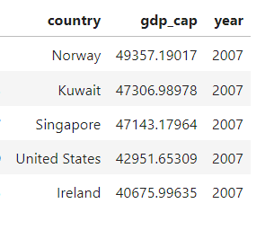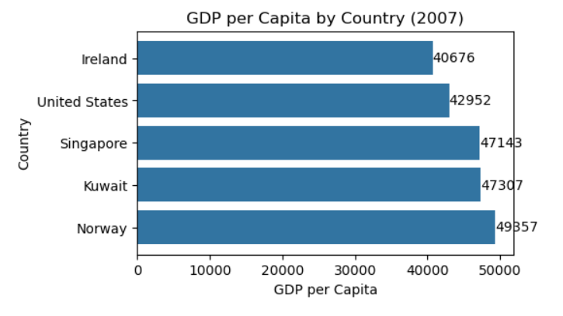

1. Find all country names that start with "I" and end with "a" using regex.

Regex Pattern used: \bI\w*a\b



Country that start with ‘I’ and end with ‘a’ are: **India** & **Indonesia**



1. Create a boxplot using Seaborn to compare the distribution of GDP per capita for each continent in 2007.

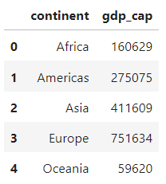

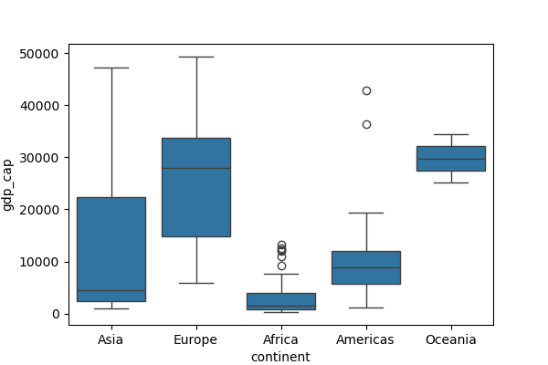

1. Find all countries with a life expectancy of over 80 years in 2007. List these countries and their respective continents.

Total number of countries (as of now) with avg life expectancy over 80 years = **13**

Countries with avg life expectancy (over 80 years) in descending order:

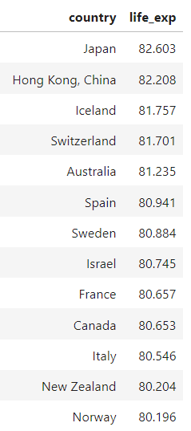

1. Convert the 'year' column to a datetime type and extract the decade. Create a new column 'Decade' that groups the years into decades (e.g., the 1950s, 1960s).

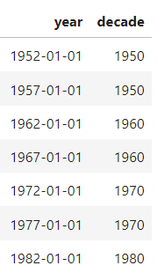

1. Compute the correlation matrix between GDP per capita, life expectancy, and population for the dataset. Then, use Seaborn to visualise this correlation matrix as a heatmap.

**Correlation Matrix:**

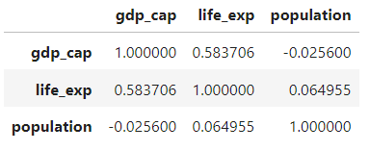

**Heatmap:**

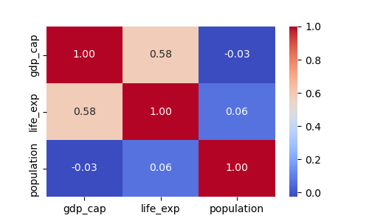

1. How has the global average life expectancy changed from 1952 to 2007? Plot a line graph to visualise this trend.

| **Decade** | **avg Life Exp (years)** |
| --- | --- |
| 1950 | 50 |
| 1960 | 54 |
| 1970 | 58 |
| 1980 | 62 |
| 1990 | 64 |
| 2000 | 66 |

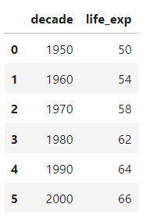 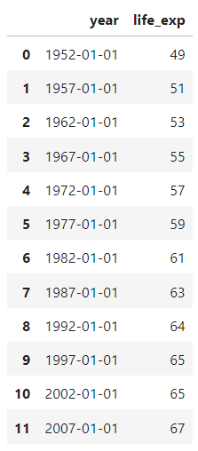

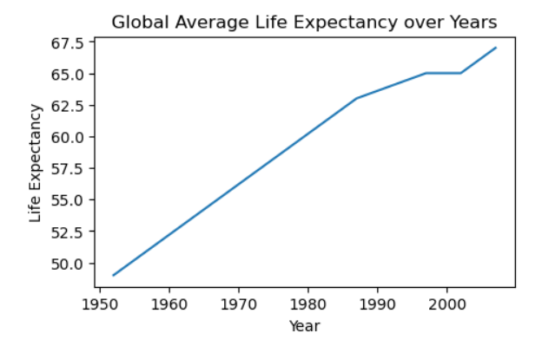

**Subjective Question**: Discuss the various reasons that could have contributed to the change.

This increase in global life expectancy include various reasons:

#### **Medical Advancements**:

* Vaccinations**:** Widespread immunisation against diseases like polio, measles, and smallpox.
* Antibiotics & Antivirals**:** Development and distribution of antibiotics and antiviral medications.
* Surgical Techniques**:** Improvements in surgical procedures and post-operative care.

#### **Public Health Initiatives**:

* Sanitation**:** Better sanitation and clean water supply.
* Health Education**:** Increased awareness and education about health and hygiene.
* Disease Control**:** Effective control and eradication of infectious diseases.

#### **Economic Growth**:

* Improved Living Standards**:** Higher income levels leading to better nutrition and living conditions.
* Healthcare Access**:** Increased access to healthcare services and facilities.

#### **Technological Innovations**:

* Medical Technology**:** Advances in medical technology, including diagnostic tools and treatment methods.
* Information Technology**:** Use of information technology in healthcare management and delivery.

#### **Globalisation**:

* Knowledge Sharing**:** Faster dissemination of medical knowledge and practices across the globe.
* International Aid**:** Increased international aid and support for health programs in developing countries. Policy and Governance:

#### **Health Policies**: Implementation of effective health policies and programs by governments.

* International Organisations**:** Role of international organisations like WHO in promoting global health.

*These factors collectively contributed to the significant increase in global average  
 life expectancy from* 1952 to 2007.

1. For the year 2007, analyse the relationship between life expectancy and GDP per capita.

Correlation b/w Life Expectancy and GDP per capita of countries = **0.68  
  
-** which is a **strong positive correlation**

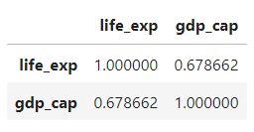

**Subjective Question:** Is there a noticeable trend or correlation? Represent this using a scatter plot.

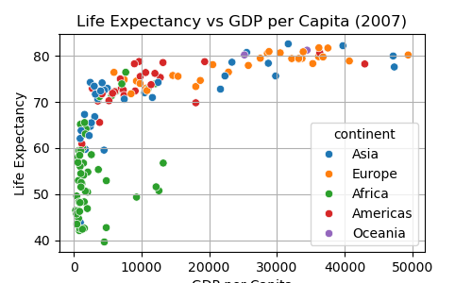

Overall Trend

* There is a positive correlation between GDP per capita and life expectancy. As GDP per capita increases, life expectancy also tends to increase.

Continental Differences

* **Africa**: African countries generally have lower GDP per capita and lower life expectancy. Most of the green dots are clustered in the lower-left region of the graph.
* **Asia**: Asian countries show a wide range in GDP per capita and life expectancy. There are countries in Asia with low GDP per capita and low life expectancy, as well as countries with high GDP per capita and high life expectancy.
* **Europe**: European countries tend to have higher GDP per capita and higher life expectancy. The orange dots are mostly concentrated in the upper-right region of the graph.
* **Americas**: Countries in the Americas also show a broad range but tend to cluster towards higher GDP per capita and higher life expectancy, though not as high as Europe.
* **Oceania**: Countries in Oceania (though fewer in number) tend to have high GDP per capita and high life expectancy.

Economic Development and Health

* Countries with higher economic development (higher GDP per capita) tend to have better health outcomes, as indicated by higher life expectancy.
* There are diminishing returns at higher levels of GDP per capita where increases in GDP per capita do not result in significant increases in life expectancy.

Concentration and Spread

* European countries are the most tightly clustered, suggesting a more uniform standard of living and health outcomes across the continent.
* African countries are more spread out, indicating more variability in economic and health outcomes.

**In summary,** the graph effectively shows the strong link between economic prosperity (GDP per capita) and health outcomes (life expectancy), with clear disparities across different continents. **While higher GDP per capita generally correlates with higher life expectancy, there are significant regional variations and outliers that suggest other influencing factors.**

1. Compare the average GDP per capita for each continent in the year 2007. Use a bar chart for this comparison.

| **Continent** | **avg GDP per Capita** |
| --- | --- |
| Africa | 3089 |
| Americas | 11003 |
| Asia | 12473 |
| Europe | 25054 |
| Oceania | 29810 |

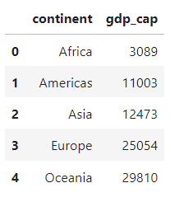 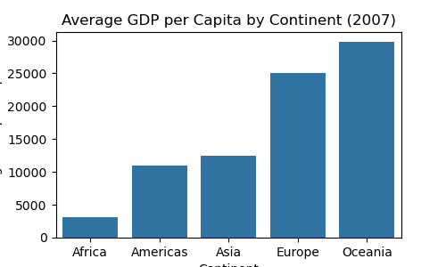

**Subjective Question**: Why is the average GDP per capita for Oceania higher than the Americas even though the Americas have more countries?

The average GDP per capita for Oceania is higher than the Americas even though the Americas have more countries because Oceania includes countries like Australia & New Zealand, which have very high GDP per capita.  
  
In contrast, the Americas include a mix of countries with varying levels of GDP per capita, including some with much lower GDP per capita, which brings down the average.

1. Compare the life expectancy and GDP per capita of Afghanistan (a country known for its historical conflicts) and Switzerland (representing a peaceful and economically prosperous country) using the dataset provided.

* Firstly, for the year 2007, use a bar chart to directly compare the life expectancy and GDP per capita between these two countries.

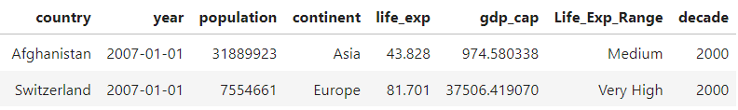

| Country | Life Exp |  | Country | GDP per Capita |
| --- | --- | --- | --- | --- |
| Afghanistan | 43.3 years |  | Afghanistan | $ 975 |
| Switzerland | 81.7 years |  | Switzerland | $ 37506 |

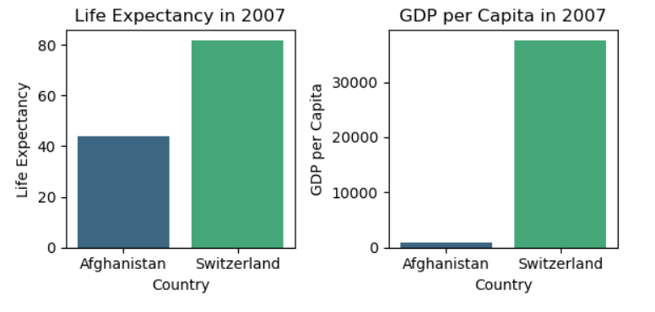

* Then, create two separate line graphs to show the trends of these two metrics over all available years in the dataset for both countries.

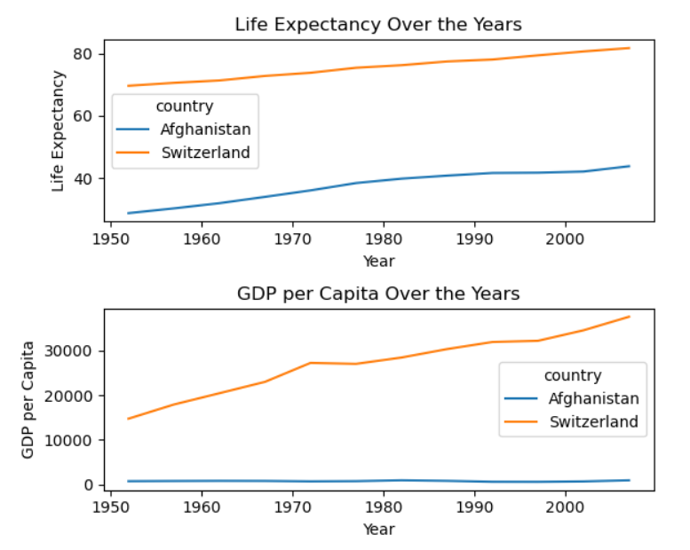

**Avg Life Expectancy every Decade:**

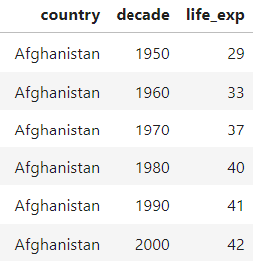 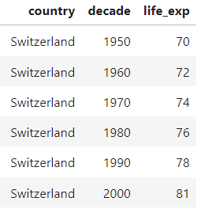

**Avg GDP per Capita every Decade:**

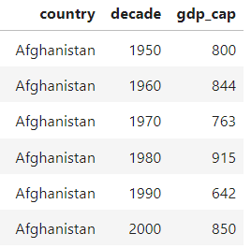 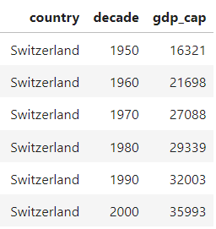

**Subjective Question**: What differences do you observe in terms of life expectancy and economic development? How might the stability or instability of a country influence these key metrics over time? Analyse the data through these visualisations and discuss your inferences.

#### Observations

**Life Expectancy**:

* Afghanistan’s life expectancy has shown a gradual increase over the years but remains significantly lower compared to Switzerland.
* Switzerland has consistently high life expectancy, with a steady increase over the years.

**GDP per Capita**:

* Afghanistan has relatively low GDP and shows minor fluctuations over the years.
* Switzerland has a high GDP per capita, which has steadily increased over the years.

#### Analysis

**Stability and Life Expectancy**:

* Afghanistan’s lower life expectancy can be attributed to various factors, including political instability, lack of access to healthcare, and ongoing conflicts. These factors contribute to higher mortality rates and lower overall life expectancy.
* Switzerland’s high life expectancy is indicative of a stable and well-developed healthcare system, higher standards of living, and better access to medical services.

**Stability and Economic Development**:

* Afghanistan’s economic development is hindered by instability, conflicts, and lack of infrastructure. These factors limit economic growth and result in a lower GDP per capita.
* Switzerland’s stable political environment, strong institutions, and robust economic policies contribute to its high GDP per capita. The country's stability attracts investments and promotes economic growth.

#### Inferences

Impact of Stability: Stability plays a crucial role in determining both life expectancy  
 and economic development. Countries with stable political environments and strong  
 institutions tend to have higher life expectancy and better economic outcomes.

Long-term Trends: The visualisations highlight the long-term trends in life  
 expectancy and GDP per capita, showing how stability and development policies  
 impact these metrics over time.

**In summary, the stability or instability of a country significantly influences key  
 metrics such as life expectancy and economic development. Stable countries like  
 Switzerland exhibit higher life expectancy and GDP per capita, while Unstable  
 countries like Afghanistan face challenges in improving these metrics.**